Name: ______________________ Period ________________________ Date ________________________
Sedimentary Rock Activities
Part I
Order the letters from oldest to youngest for the following geologic formations. Youngest
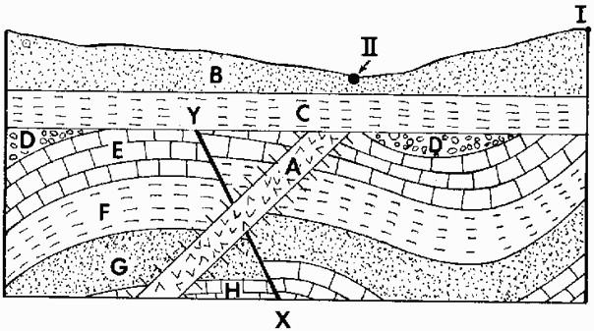
_________
_________
_________
_________
_________
_________
_________
_________
_________
_________
_________
_________ Oldest
Part II
Below we have six core samples that came from the same region. We need you to determine which layers correlate by drawing a line from the top and bottom of each layer to the next. See below for an example. If there is a layer that has no match in the next column it is called a pinch out and will just form a point/triangle (also seen below).
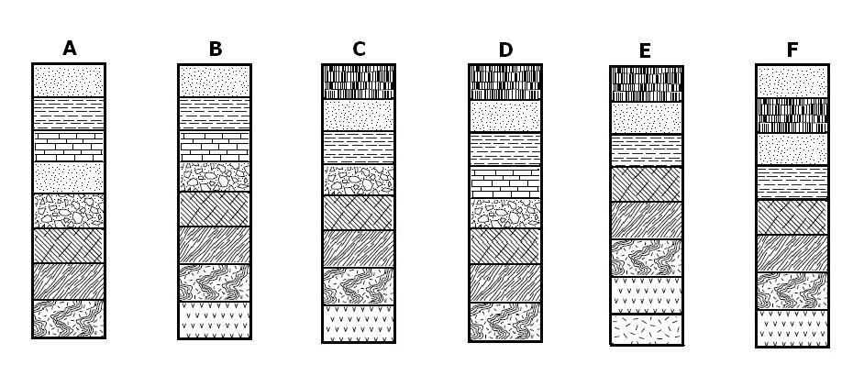
How many layers pinch out? What happen to the pinched out layers, what are some reasons it didn’t continue across?
Part III
Each strip represents a sedimentary rock layer formed during a certain time period. Put the layers in correct order. Begin by placing B, the “oldest layer,” on the bottom. Then decide which layer comes next. It will have some of the same organisms as the older layer and some new ones. (Hint: Organisms do not disappear for a layer and then reappear.) Place it above. Continue until the layers are in order, with the youngest at the top.
Look at the fossils within each layer. What plants and animals lived during the same time period? Then compare the layers to explore the changing plant and animal groups throughout Earth’s history. Which organisms survived from one time period to the next? Which ones went extinct? Could Tarbosaurus have hunted Seismosaurus? What organisms survived the mass extinction at the end of the Cretaceous Period?
Glue/tape the cut up strips below in the box

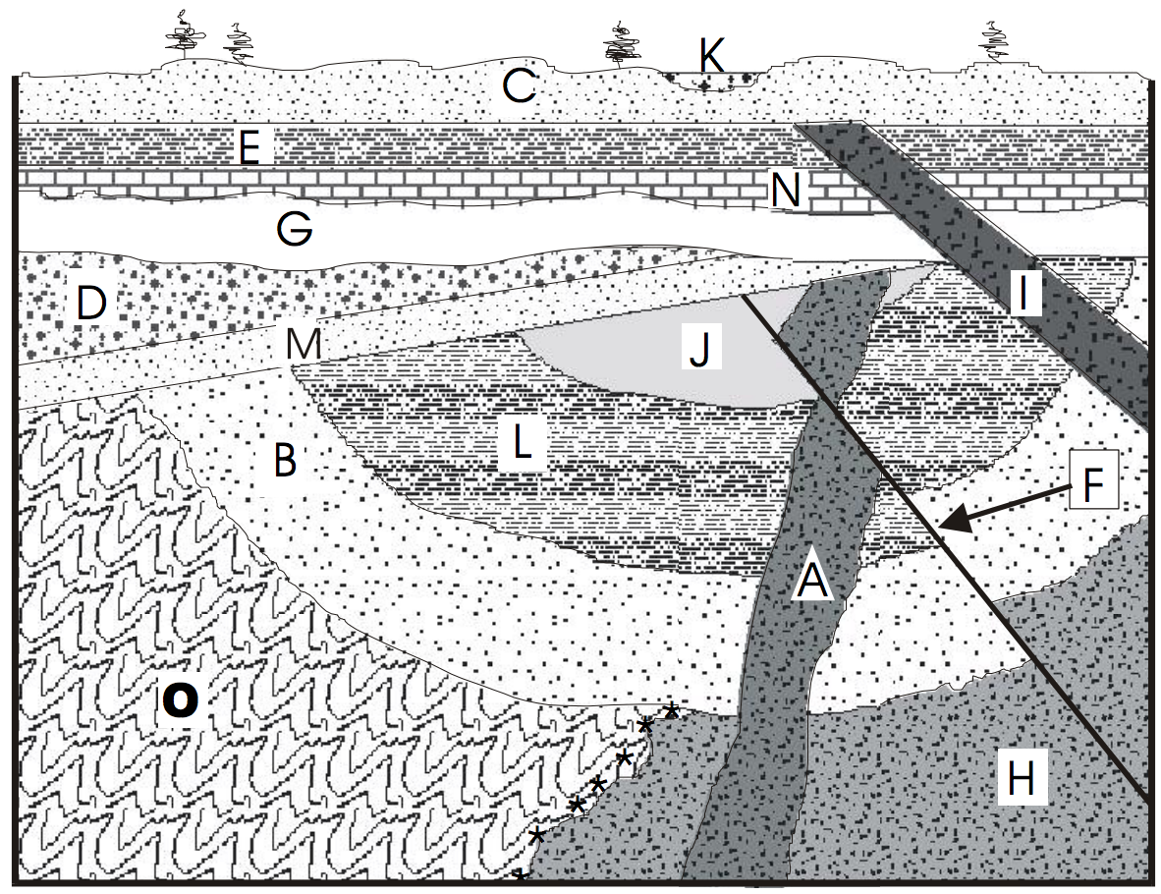
Here’s a hard one. Can you list the order the occurred?
________ Youngest
________
________
________
________
________
________
________
________
________
________
________
________
________ Oldest

