NAMES:______________________________________________________________________________
Save the People of Chile!
With recent earthquakes in the last few decades we’ve been able to map the placement of earthquakes of all sizes along the coast of South America. Chile is long overdue for a big earthquake in this area and that could trigger earthquakes up and down the coast. The other issue is the volcanic activity produced by subduction zones; we need to know where those will pop up to evacuate larger cities, if needed.
We need your expertise to accomplish the following:
- Using a sheet of graphing paper. Graph the subducting Pacific Plate under the South American Plate. Remember that earthquakes happen all along the subducting plate. By setting your graph to be 1:1 by depth and distance (800 km deep by 800 km distance) you can plot the information and find the angle it dips into the earth. You’ll need a protractor to find that dip.
- Mark on your map where the volcanic arc will form along the coast. Refer back to your notes (or internet) for where this occurs based off depth of the subducting plate.
- Look for patterns along the coast based off the section you mapped to see where other volcanoes could occur. Mark them with a triangle (Δ) in the general area they should form.
- Identify the igneous rocks’ names that were extracted near the volcanoes to determine the type of volcanoes and whether it’ll be explosive. Felsic are more explosive due to being silica rich and mafic tend to be runny.
  - Volcano Rock #1_________________________ Felsic or Mafic
  - Volcano Rock #2_________________________ Felsic or Mafic
  - Volcano Rock #3_________________________ Felsic or Mafic
  - Volcano Rock #4_________________________ Felsic or Mafic
- With your research and any other information, write below a summary of your findings and your recommendation of what to do for those living in Chile.

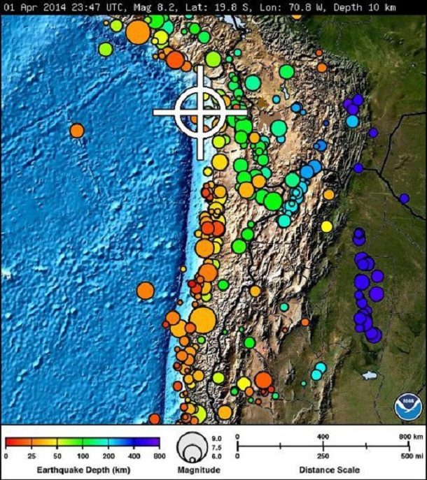

Use the distance scale and plot all the points within that distance from the trench to the dark colored earthquakes on the right. Make sure to plot them at the correct depth, too (scale on the bottom left).
Graph the earthquakes below. Use the distance from the trench to each earthquake along your drawn line and then determine the depth of each earthquake based on the color of each. Plot the distance against the depth below on the graph.
Distance from the Trench in Kilometers
0 50 100 200 300 400 500 600 700 800
Depth of the Earthquakes by Kilometers
0
100
200
300
400
500
600
700
800

